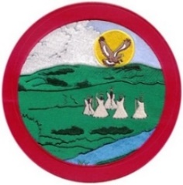
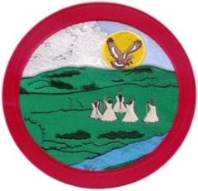
Kahkewistahaw 1907 Trust
CDA Amendments/Christmas Dinner

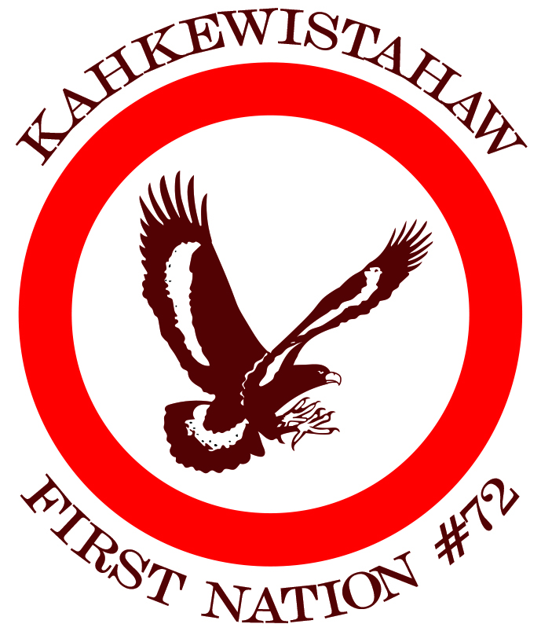

Kahkewistahaw First Nation Calgary
Wednesday, December 1,2021 Friday, December 10, 2021
Kahkewistahaw Complex Best Western Premier Plaza-1316 33 St NE
Trust Info Session: 10:00 am – 12:00 pm Trust Info Session: 10:00 am - 12:00 pm
Advance Polling: 1:00 pm. to 8:00 pm Advance Polling: 1:00 pm – 8:00 pm
Christmas Payout: 1:00 pm - 7:00 pm Christmas Payout: 1:00 pm – 7:00 pm
Christmas Dinner: 5:30 pm – 6:30 pm

Yorkton Edmonton
Thursday, December 2, 2021 Saturday, December 11, 2021
Painted Hand Casino Holiday Inn
510 Broadway St. W 4485 Gateway Blvd
Trust Info Session: 10:00 am – 12:00 pm Trust Info Session: 11:00 am – 12:00 pm
Advance Polling: 1:00 pm to 8:00 pm Advance Polling: 1:00 pm – 8:00 pm
Christmas Payout: 1:00 pm – 7:00 pm Christmas Payout: 1:00 pm – 7:00 pm
Christmas Dinner: 5:30 pm - 6:30 pm Christmas Dinner: 12:00 pm – 1:30 pm

Regina Vancouver
Saturday, December 4, 2021 Monday, December 13, 2021
Delta Hotel River Rock Casino – 8811 River Rd
1919 Saskatchewan Dr. Richmond, BC
Trust Info Session: 10:00 am – 12:00 pm Trust Info Session: 10:00am -12:00pm
Advance Polling: 1:00 pm - 8:00 pm Advance Polling: 1:00 pm – 8:00 pm
Christmas Payout: 1:00 pm – 7:00 pm Christmas Payout: 1:00 pm – 7:00 pm
Christmas Dinner: 12:00 pm – 1:30 pm Christmas Dinner: 5:30 pm – 6:30 pm

Saskatoon Kelowna
Monday, December 6, 2021 Tuesday, December 14, 2021
Saskatoon Inn – 2002 Airport Dr. Delta Hotel – 1310 Water St.
Trust Info Session: 10:00 am – 12:00 pm Trust Info Session: 11:00 am – 12:00 pm
Advance Polling: 1:00 pm - 8:00 pm Advance Polling: 1:00 pm – 8:00 pm
Christmas Payout: 1:00 pm – 7:00 pm Christmas Payout: 1:00 pm – 7:00 pm
Christmas Dinner: 5:30 pm - 6:30 pm Christmas Dinner: 5:30 pm – 6:30 pm

Winnipeg Kahkewistahaw First Nation
Wednesday, December 8, 2021 Thursday, December 16, 2021
Clarion Hotel – 1445 Portage Ave Kahkewistahaw Complex
Trust Info Session: 10:00 am – 12:00 pm Voting Day: 1:00 pm – 8:00 pm
Advance Polling: 1:00 pm – 8:00 pm Christmas Payout: 1:00 pm – 7:00 pm
Christmas Payout: 1:00 pm – 7:00 pm
Christmas Dinner: 5:30 pm – 6:30 pm

Covid 19 protocols will be followed in each province.

