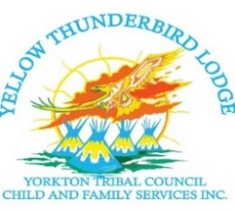
⁸
Prevention Services
Advocacy, Services, Support

Recruitment Opportunity

Yellow Thunderbird Lodge
Wahkotowin Intervention Safe Home

We are Accepting Applications for:
- Full Time Employees
- Casual Employees

April 7, 2022
10:00 am – 3:00 pm

To be held at:
Kahkewistahaw First Nation- Governance Centre

Must have Valid License

Bring your Resume

Successful Candidates will receive an interview time scheduled for April 13, 2022.

Inquiries call: Pamela Martell (306) 620 6852

